主题：电子游戏

题型：柱状图（动态图）

The bar graph shows the global sales (in billions of dollars) of different types of digital games between 2000 and 2006.

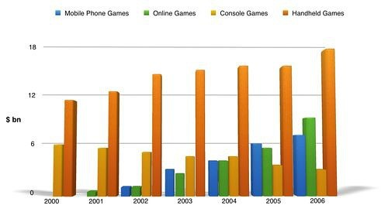

满分范文：

The bar chart compares the turnover in dollars from sales of video games for four different platforms, namely mobile phones, online, consoles and handheld devices, from 2000 to 2006.

It is clear that sales of games for three out of the four platforms rose each year, leading to a significant rise in total global turnover over the 7-year period. Sales figures for handheld games were at least twice as high as those for any other platform in almost every year.

In 2000, worldwide sales of handheld games stood at around $11 billion, while console games earned just under $6 billion. No figures are given for mobile or online games in that year. Over the next 3 years, sales of handheld video games rose by about $4 billion, but the figure for consoles decreased by $2 billion. Mobile phone and online games started to become popular, with sales reaching around $3 billion in 2003.

In 2006, sales of handheld, online and mobile games reached peaks of 17, 9 and 7 billion dollars respectively. By contrast, turnover from console games dropped to its lowest point, at around $2.5 billion.